Lakshmi Narain College of Technology & Science, Bhopal

Department of Electronics and Communication Engineering

Name: Madhuri Darkar Enrolment no.:0157EC181048 Class: EC V D

Date: 25/08/20 Page no.: 07

**PRACTICAL-2**

Aim: Write a program to perform various vector operations.

Software required: Scilab version 6.0.2

Define two vectors A and B where

A= [1 5 8 19]

B= [19 8 5 1] and perform calculations.

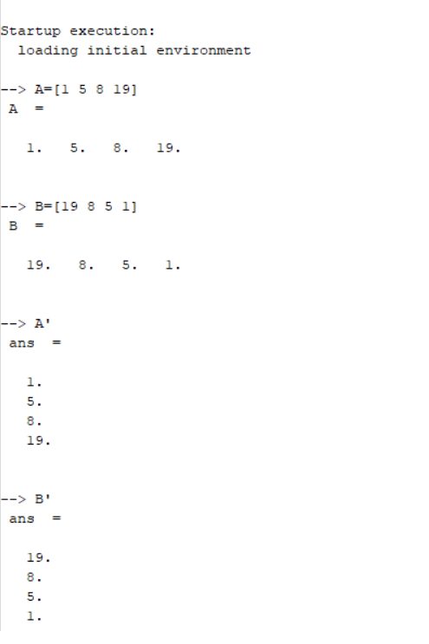

Lakshmi Narain College of Technology & Science, Bhopal

Department of Electronics and Communication Engineering

Name: Madhuri Darkar Enrolment no.:0157EC181048 Class: EC V D

Date: 25/08/20 Page no.: 08

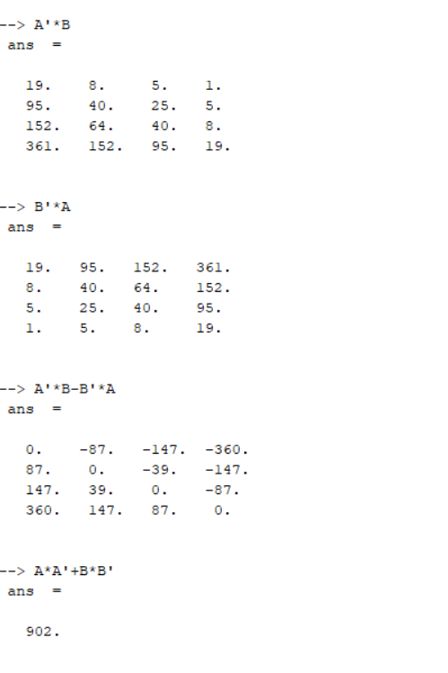

Teacher’s signature